Game Design Document

Fill up the Following document

1. Write the title of your project.

Run thief run !!

1. What is the goal of the game?

The goal of the game is to destroy the obstacles that are trying to capture you.

1. Write a brief story of your game?

A thief, named “Oliver” has stolen a

precious stone from a castle and is

lost in a deep forests and is also

continuously being attacked by

weapons thrown by the soldiers of

castle and he has to hit the weapons

so that he can survive.

1. Which are the playing characters of this game?

* Playing characters are the ones which respond to the user based on the input from the user
* Cars, monkeys, dinos, wizards etc, are the playing characters in the game.

|  |  |  |
| --- | --- | --- |
| Number | Character Name | What can this character do? |
| 1 | OLIVER(thief) | He can shoot the obstacles that are trying to capture him. |

1. Which are the Non Playing Characters of this game?

* Non Playing characters are the ones which don't have an action or a behaviour when the user interacts with the game.
* Hurdles, stones, bananas, coins, etc are non playing characters in the game.

|  |  |  |
| --- | --- | --- |
| Number | Character Name | What can this character do? |
| 1 | Weapons | If the thief gets trapped by it then he will die. |
| 2 | Arrow | Helps the thief to destroy the weapons |

Draw your imagination of this game. What does this game look like?

* Draw the game either on your computer or on paper,
* Add images of scenes of the game to show each of the playing and non-playing characters at least once.

Starting of the game.

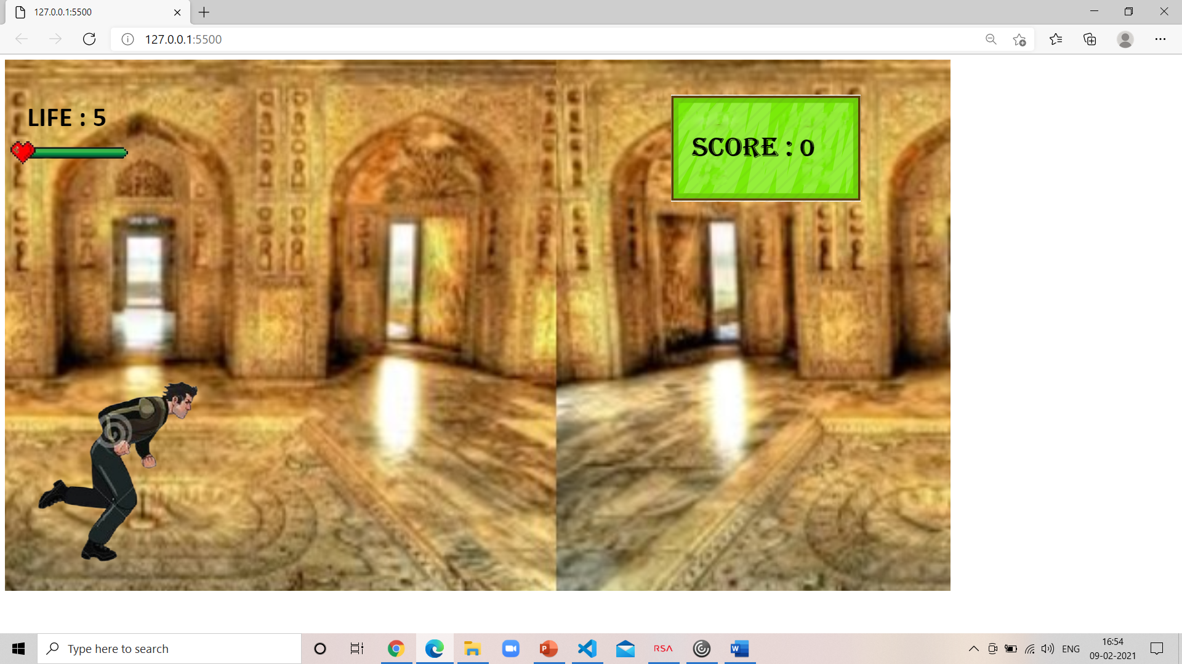

Player shooting obstacle.

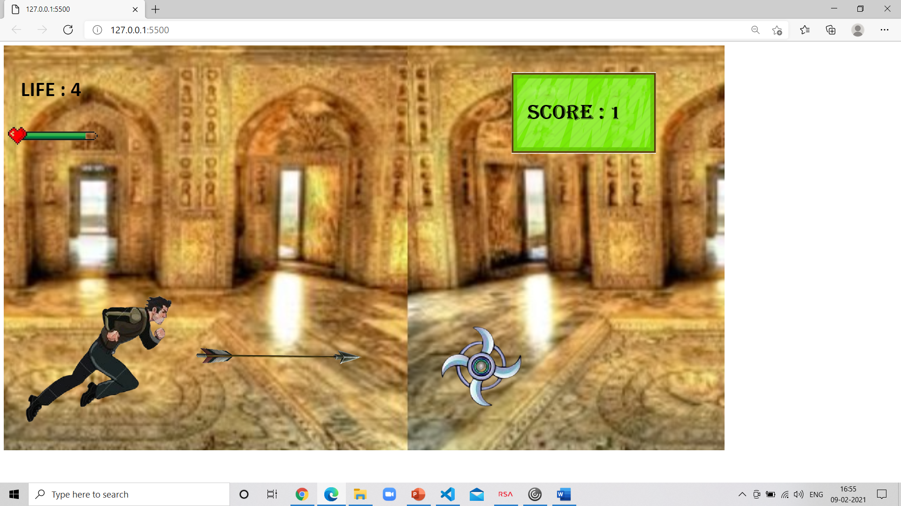

Next level.

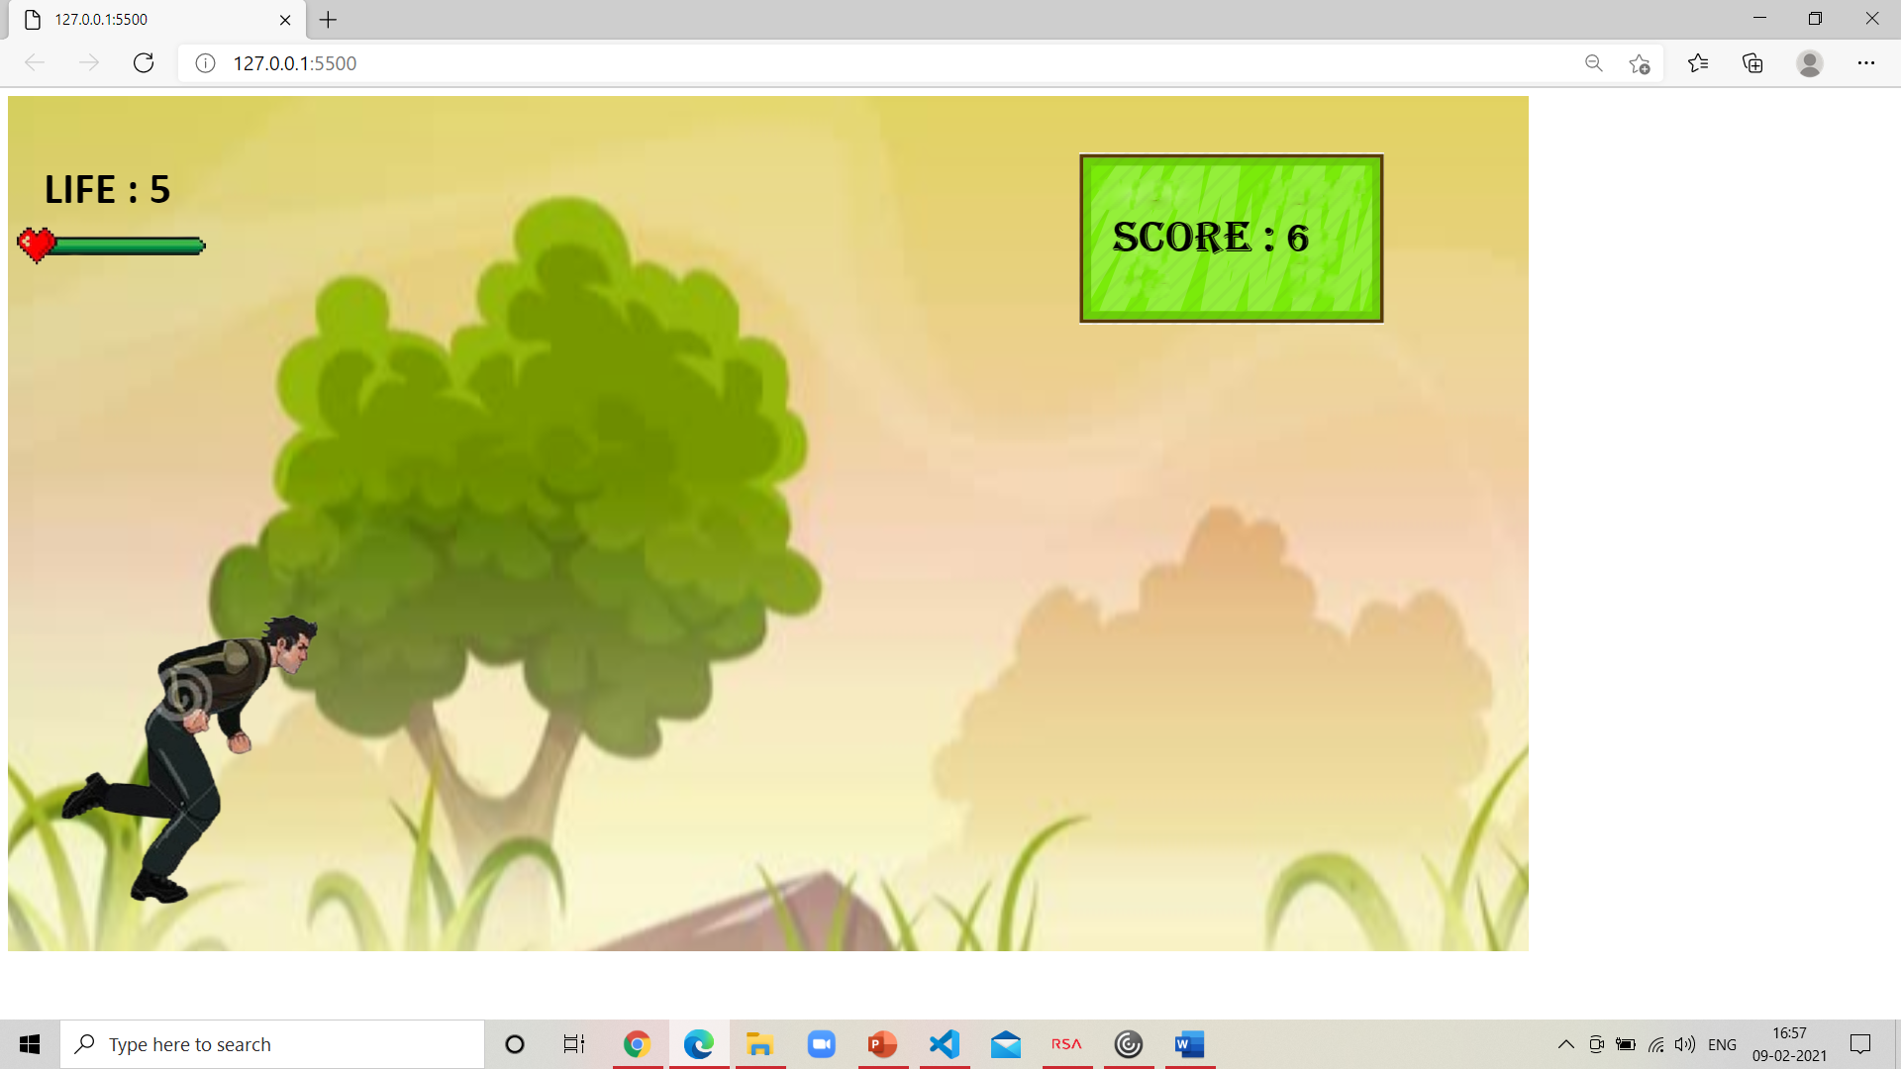

Screen when obstacle touches player.

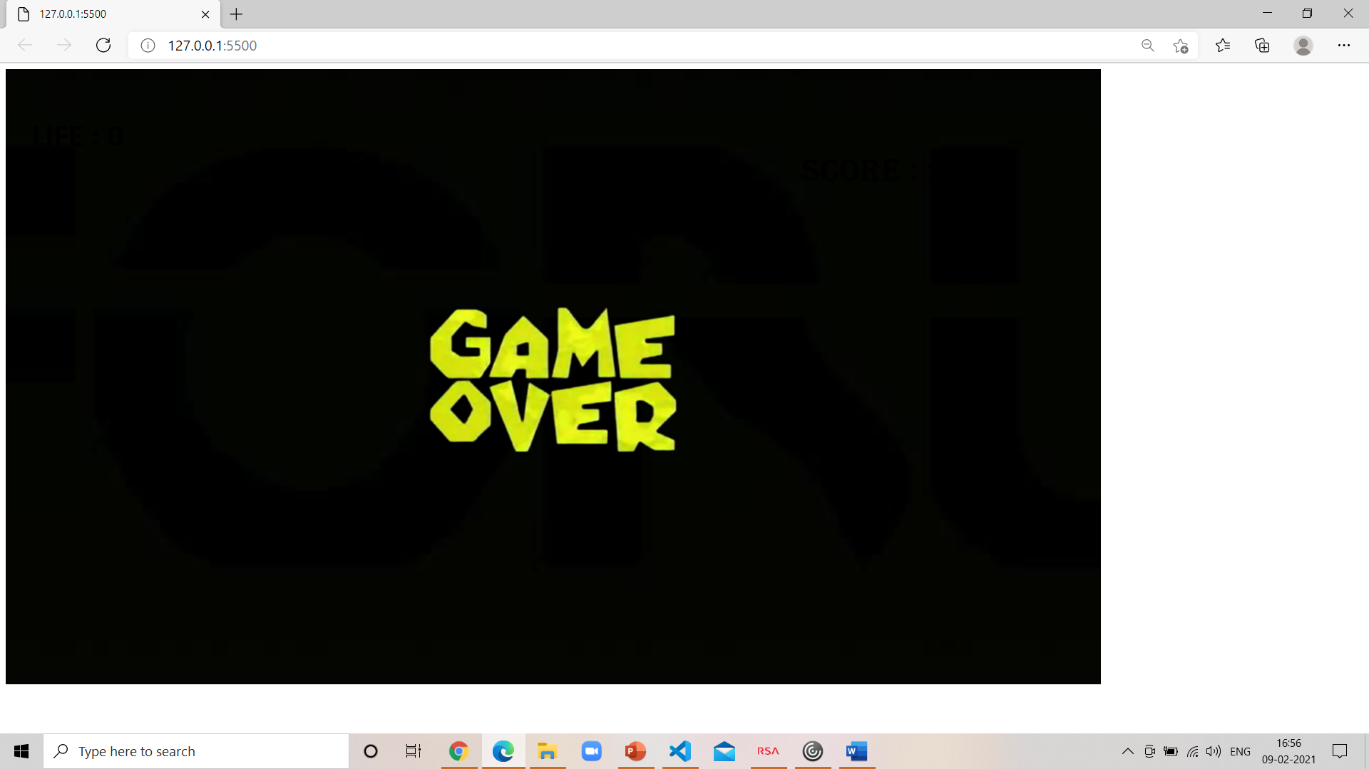

1. How do you plan to make your game engaging?

I plan to make my game engaging by

adding levels, giving the player lifes

& also by adding attractive images.